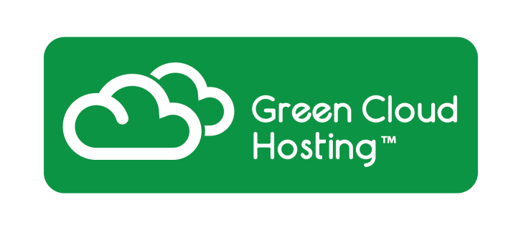

Hosted Lync platform Tel 0800 019 3878

Green Cloud provides Hosted Lync through 2 platform options

- Multi-tenant
- Dedicated

Right now Green Cloud is one of the only providers to deliver full PSTN break out via a multi-tenant platform.

Microsoft Lync 2010 is a next generation unified communications (UC) technology that integrates seamlessly with IT infrastructures to provide enterprise class voice, secure business messaging and conferencing capabilities from a single unified client, transforming every communication into an interaction that is more collaborative, engaging and accessible from anywhere. Microsoft Lync 2010 communications software creates a virtual connection between you and the people you work with. It lets you talk, share your desktop and programs, and work together in real time, all from your computer.

Benefits
- Integrated Telecoms & IT – full PBX capabilities integrated into Microsoft Exchange, SharePoint and Dynamics CRM, and bringing carrier-grade voice communications to your PC/laptop
- Control Costs – reduce travel and communication costs by routing calls through your IP network using inbuilt video and voice conferencing capabilities of Microsoft Lync 2010
- Improve Productivity – use presence to see availability of colleagues and choose the most effective way of communicating including desktop sharing in real time
- Support your mobile workers – access vital business tools and information through any internet enabled device via Microsoft Lync 2010 without the implementation of expensive VPN’s
- Be more responsive – Instant messaging and group chat allows disparate groups to communicate instantly, eliminating or reducing delays when answers to questions are needed quickly

Features
- Unified experience – access presence, instant messaging, voice, video and Web conferencing in a single interface
- Communicate from within the applications you use every day, including Microsoft Outlook and Microsoft SharePoint
- Collaborate more effectively with built-in desktop and application sharing, PowerPoint upload and rich white boarding
- Schedule and join meetings with a single click in Microsoft Outlook or the meeting reminder
- Microsoft Lync 2010 delivers Enterprise voice features, giving users the ability to work in the office, at home or on the road

